Reflections from Bible Study March 13, 2024
Teacher: Co-pastor Claudene Campbell

Deuteronomy 28:2-3
Deu 28:2 And all these blessings shall come on thee, and overtake thee, if thou shalt hearken unto the voice of the LORD thy God.
Deu 28:3 Blessed shalt thou be in the city, and blessed shalt thou be in the field.

Reflection by Bro. Andrew:
Blessing our work and blessing what we are building with our wealth

Reflection by sis. Barb: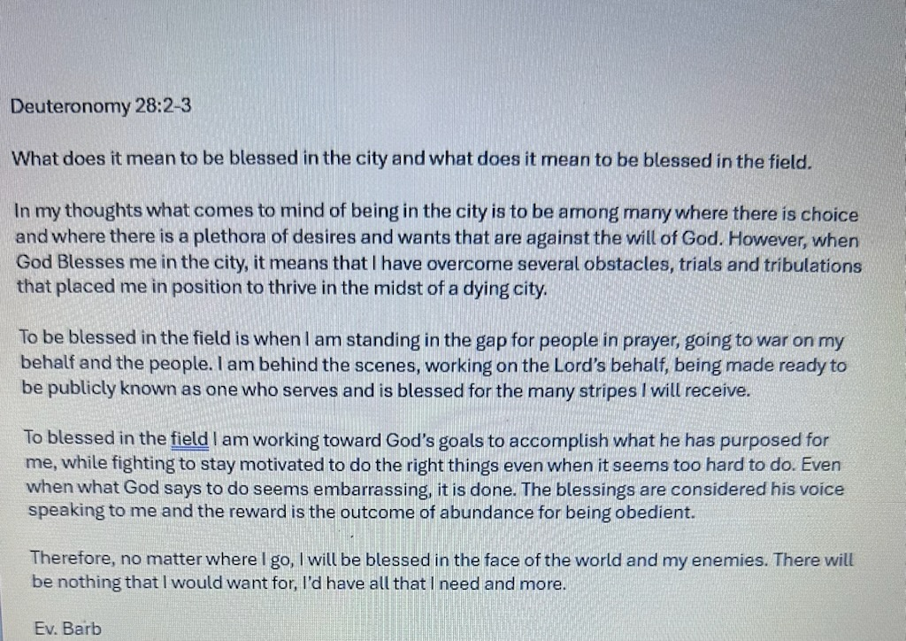

Reflection by sis. Princess
NOTE: The images were originally attached underneath the definitions. But even without the images, I believe the point still comes across.

“He’s taking us in the city and in the field with our blessings. What does it means to be in the city and what does it means to be in the field?”

We are blessed in the cities:

A city is larger, and generally more important than a town or village. We are blessed in the larger, more known, relevant and more significant places. Our blessings are acknowledged and seen. Our blessings are bigger. Our blessings are more impactful.

We are blessed in the field:

A field can be an open area of land.

Field can describe your area of expertise or work or education

Field can be used to describe viewpoint

Field can be used to understand a space in physics where force is exerted.

Field can be used synonymously with deploy or to take on/deal with.

What if when he says field, he’s blessings us in all of these areas??

Open land: Blessed with land or, generally speaking, blessing us with abundance through ownership.

Work/Education/Expertise: Blessed with prosperity and success in our businesses.

Viewpoint: Blessed with the expansion of our way of thinking.

Physics: Blessed in the exertion of force. If we have to fight, we win. Any battle. Spiritual or natural.

Deployment/Coping: Blessed whenever we have to take on anything that comes against us. Blessed in our positioning!

Maybe the words field and city were used to describe the all-encompassing and expansive way in which God intends to bless us. All with the requisite to obey, first. (Deut 28:2 before Deut 28:3)

Additionally, I expect that with having these blessings so abundantly comes with charity as well. Sharing the wealth of my knowledge and strength. Helping those who may be struggling where I once struggled. Using my testimony and experience to guide those who are navigating similar tests/trials. There is responsibility and accountability attached.

Father I pray: When I think about what I am, have and will go through- May I never grow weary another day. For what I experience is not for me alone, but to help God’s children who will experience the same. May I always accept the trials I experience humbly and with grace while continually leaning on God as my help and comforter. In Jesus name.

